# **General info on Malaysia’s MCO**

# **MCO – Movement Control Order**

As of 15th April 2020, there are 3 stages of MCO taking place in Malaysia:

MCO I – 18th March 2020 till 31st March 2020

MCO II – 1st April till 14th April 2020

MCO III – 15th April till 28th April 2020

After a month of MCO (Phase 1 & 2), total of new cases is in controlled (without major increment) AND total of discharged patients increased.

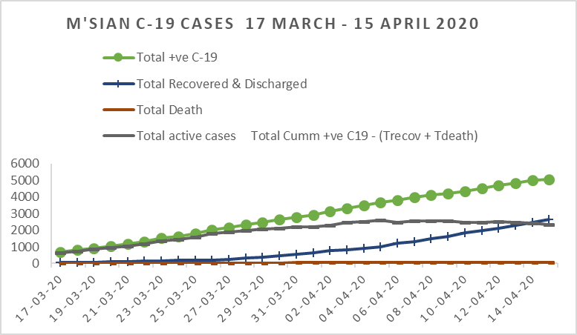

MCO 1

MCO 2

MCO3

Figure 1: Report of Covid-19 patients based on data released by Ministry of Health Msia.

**Media release on 15th April 2020 by the Director of Min of Health, Malaysia**

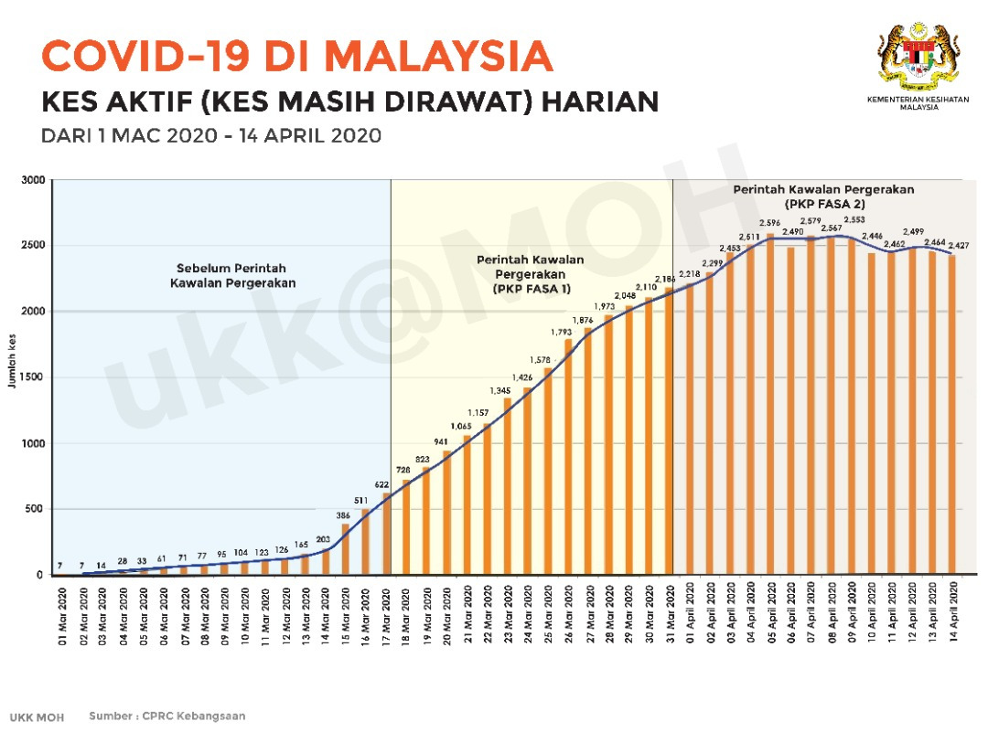

Legend: Blue – before MCO Pink – MCO 1 Grey – MCO 2

Figure 2: Active cases (still on treatment) from 1st March 2020 till 14th April with 2 phases of MCO (18th March – 14th April)

Summary Analysis Following the Second Phase of the Movement Control Order

As announced by the Prime Minister, the second phase of the Movement Control Order (MCO) from 1 April 2020 to 14 April, 2020 has now been extended into the third phase. After nearly one month of the implementation of phase one and two of the MCO, the trend of new COVID-19 cases was relatively stable without any sudden increases. In addition, the number of daily cases recovered and discharged well from the wards has increased. These are encouraging outcomes of the implementation of the MCO, as also demonstrated by the trend of daily active cases.

Following the first and second phase of the MCO, phase three of the MCO is enforced starting today, 15 April 2020 until 28 April 2020. The main aim is to continue to support MOH’s existing measures and to intensify further efforts to reduce the number of COVID-19 positive cases in Malaysia by using a targeted approach.

The compliance of the community with the MCO is crucial at this stage. However, based on the monitoring by the authorities and of the road traffic situation recently, it appears that the public is less compliant towards the MCO.

In this regard, MOH welcomes the decision by the National Security Council that more severe action will be taken against the few members of the community not complying to the MCO. It is hoped that this will lead to a positive impact in flattening the epidemic curve and thus ensure that MOH healthcare facilities are able to manage all COVID-19 patients. MOH is concerned that non-compliance to the MCO can negate and undo all the hard work that has been done so far. MOH thanks all the related agencies for assisting in the enforcement of the MCO to ensure that the level of compliance can be further improved.

MOH, therefore, calls on the cooperation of all Malaysians to play their part as responsible citizens in ensuring that the COVID-19 infection transmission can be broken. This can be achieved by continuing to practice the following:

Compliance with the MCO

Consistently maintain a high standard of personal hygiene such as washing hands frequently with water and soap

Practice social distancing of at least 1 metre away from others

MOH is also aware that a number of individuals are required to attend to work especially those in essential services. MOH, therefore, advises them to:

Avoid being in crowded and confined spaces with many people, e.g. work pantry

Maintain a distance of at least 1 metre when having face-to-face conversations

Ensure any dining areas in the office remains clean, and use disinfectants for frequently touched common surfaces

**Media release on 13th April 2020 by the Director of Min of Health, Malaysia**

**Current Status of Confirmed COVID-19 Cases Who Have Recovered**

13 April 2020 – The Ministry of Health (MOH) would like to inform that **168 cases** have fully recovered and discharged well today. **Cumulatively, 2,276 confirmed COVID-19 cases have fully recovered and discharged well** (47.23% of total cumulative cases). **Again, the number of cases discharged today is higher than the number of additional confirmed cases reported**.

**Current Situation of COVID-19 in Malaysia**

13 April 2020, 12 pm – A total of **134 additional confirmed COVID-19 cases** were reported to the National Crisis Preparedness and Response Centre (CPRC) MOH today. Cumulatively there are now **4,817 confirmed COVID-19 cases** in Malaysia. After removing cases discharged well and deaths, there are **currently 2,464 active and infective COVID-19 cases**. They have been isolated and provided treatment.

Currently, **66 confirmed COVID-19 cases are receiving treatment in intensive care units (ICU)**, and of these, 36 cases are on ventilation support.

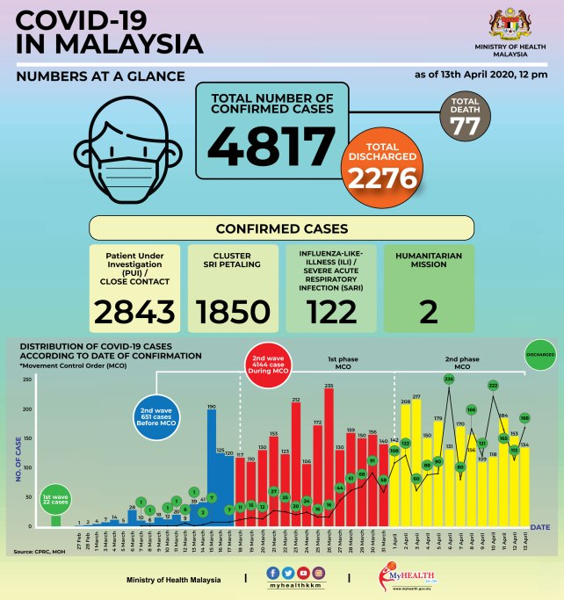

# **The following are some online articles related to MCO.**

# **Malaysia may have flattened pandemic curve at end of MCO Phase 2, says Health DG**

[Emir Zainul](https://www.theedgemarkets.com/author/Emir%20Zainul)

/

[theedgemarkets.com](https://www.theedgemarkets.com/source/theedgemarkets.com)

April 14, 2020 20:33 pm +08

KUALA LUMPUR (April 14): As the nation approaches the third phase of the Movement Control Order (MCO) starting tomorrow, Ministry of Health (MoH) director-general Datuk Dr Noor Hisham Abdullah said the first two phases of the MCO may have achieved its objective of "flattening the curve".

Making a comparison with the projection made by JP Morgan Chase & Co last month, Noor Hisham said the MCO has definitely managed to record fewer Covid-19 cases compared with what was initially forecasted by the international investment bank.

"Today was supposed to be the peak [according to the prediction] but we have not seen a peak in terms of the graph, so perhaps we have managed to flatten the curve. Obviously, we have seen a lower number of cases compared to what was predicted," he told reporters today during his daily briefing of the Covid-19 situation in the country.

"But, more importantly, more needs to be done. This is why we are monitoring it closely and hopefully the third phase of MCO will help us further," Noor Hisham added.

A report released by JPMorgan’s Asia-Pacific Equity Research group on March 23 projected that Malaysia will see a peak in Covid-19 cases at around mid-April, with 6,300 cases.

It projected that the peak period would last for about one-and-a-half to two weeks, before moving into the accumulation stage, when the overall infection growth rate would slow to 100 to 250 cases per day.

However, MoH reported that the tally of Covid-19 cases in the country currently stands at 4,987 — much lower than JPMorgan's forecast — following the addition of 170 new infections at noon today.

More encouragingly, 2,478 Covid-19 patients — representing 49.7% of total cases — have, to date, recovered from the illness.

This means that the number of active Covid-19 cases in the country now stands at 2,427, all of whom have been isolated and are currently receiving treatment.

Dr Noor Hisham previously said that the purpose of the MCO was to flatten the infection curve, which means to contain the total number of cases so that hospitals across the country would be able to cope with the inflow of patients.

This, however, does not mean that the number of infections would be brought down to zero.

# MCO Phase 1, 2 fruitful but Phase 3 most important

###### [Harits Asyraf Hasnan](http://english.astroawani.com/news/author/harits-asyraf-hasnan)**,** Astro Awani | Diterbitkan pada

###### April 13, 2020 21:45 MYT

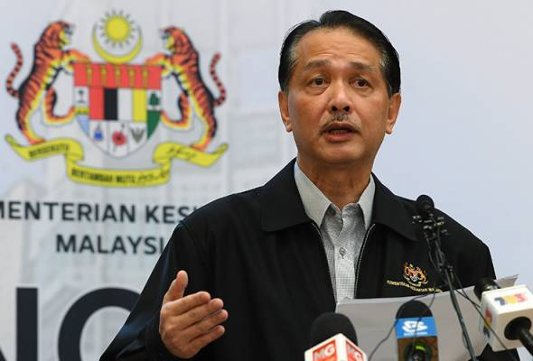

NOOR HISHAM: We need to bring it down further and that is why the MCO Phase 3 is so important.

**PUTRAJAYA**: The Ministry of Health (MOH) has described the implementation of the Phase 1 and 2 of the Movement Control Order (MCO) following the COVID-19 outbreak as successful in producing positive results.  
  
Director-General of Health, Datuk Dr Noor Hisham Abdullah said it had also denied an earlier projection that Malaysia would face more than 6,000 COVID-19 positive cases by mid-April.

“I expect that tomorrow, we will be able to reduce the case to 5,000 while demonstrating that our actions throughout MCO 1 and 2 have been successful.  
  
"This is a sign of success that we have been able to control the number of cases and gradually flattening the curve," he told a daily media conference on COVID-19 here today.

Dr Noor Hisham explained that when observing the data in the 13th week, there has been a peak in the daily trend of cases.  
  
"We hope we are in the recovery phase. We are still closely monitoring it because it has not yet fully come down.  
  
“We need to bring it down further and that is why the MCO Phase 3 is so important.  
  
"If we succeed in doing so, it is possible for us to reduce the case, not only to flatten the curve but also to end the spread of the COVID-19 outbreak in the country," he said.  
  
Previously, Malaysia is expected to face the peak of the COVID-19 case in mid-April, which forecast that the country will face more than 6,000 cumulative cases.  
  
JP Morgan has actually predicted that Malaysia may have peak cases on April 14, which is tomorrow with a projection of 6,300 cases but today the country has seen 4,817 cumulative cases.

# Malaysia’s Covid-19 curve steepening since MCO

[Emir Zainul](https://www.theedgemarkets.com/author/Emir%20Zainul)

/

[The Edge Financial Daily](https://www.theedgemarkets.com/source/The%20Edge%20Financial%20Daily)

April 06, 2020 10:01 am +08

KUALA LUMPUR: Another 179 new Covid-19 cases were reported in Malaysia yesterday, bringing the total to 3,662. Of these, 46 were traced to the tabligh gathering that took place at the Seri Petaling Jamek Mosque between Feb 27 and March 1.

Since the movement control order (MCO) was enforced on March 18, the total number of cases has risen more than fivefold from 673 cases at the time. Over the past week, 1,192 new positive cases have been recorded.

There were four new deaths, all of them aged 50 years and above, raising the country’s death toll to 61 or 1.67% of the total confirmed Covid-19 cases. This compares with the global Covid-19 death rate of 5.4%. Over the past week, 26 new deaths were recorded in Malaysia.

Meanwhile, 90 patients were discharged yesterday, raising the number of recovered cases in Malaysia to 1,005 or 27.4% of the total. This is a significant increase over the 388 recovered cases reported as of last week. In comparison, 253,670 patients have recovered globally, accounting for 20.9% of the total number of cases reported worldwide.

Currently, 99 patients are being treated in intensive care units, with 48 of them requiring respiratory assistance.

Speaking at the daily media update on the Covid-19 outbreak in Putrajaya yesterday, Health director-general Datuk Dr Noor Hisham Abdullah said the health authorities have screened 17,012 attendees of the tabligh assembly in Seri Petaling.

So far, 1,591 positive cases related to the Seri Petaling tabligh cluster have been recorded, while 10,912 have tested negative. The results for another 4,500 samples are still pending.

“Nonetheless, we would like to take this opportunity to thank the syura council of the tabligh group that has given us full cooperation in terms of localising their members as well as advising their members to come forward for testing,” said Noor Hisham.

“We also learnt that some of the tabligh group members are still overseas, for example in India, Indonesia and Pakistan. So they have not returned yet ... when they are back, we need to work with the police again as well as the immigration department to make sure that they come forward for the testing,” he added.

As for the four new deaths, Noor Hisham said the first involved a 72-year-old man who had a history of diabetes and high blood pressure. He contracted the virus through direct contact with patient No 1,031 and had been treated at Sarawak General Hospital in Kuching from March 27 until he passed away yesterday.

Another death was also recorded at Sarawak General Hospital yesterday involving a 53-year-old man.

Next was a 68-year-old man who also had a history of diabetes. He passed away yesterday at Hospital Kuala Lumpur.

The nation’s 61st death involved a 66-year-old man with a history of diabetes, high blood pressure and kidney disease. He had been treated at Hospital Keningau in Sabah from March 26 until he passed away last night.

“The ministry of health extends its condolences to the families of the deceased,” Noor Hisham said.

In terms of areas, Lembah Pantai in Kuala Lumpur remains as the red zone area with the highest number of infections in Malaysia, followed by Petaling and Hulu Langat, both in Selangor.

On Saturday, the authorities added two new areas — Jerantut in Pahang and Batu Pahat in Johor — into the red zone category, namely areas with more than 40 positive cases.

With the additional two, there are now 17 red zone areas, seven of which are in the Klang Valley. Other red zone areas include Seremban, Johor Baru, Kluang, Kepong, Klang, Titiwangsa, Kota Baru, Kinta, Gombak and Hilir Perak. There are also two red zone areas in East Malaysia, which are Kuching and Tawau.

At the time of writing, the number of Covid-19 cases in the US — the country leading the world in the total number of cases — has exceeded 312,000, while the death toll has passed 8,500.

In Italy, the death toll rose to 15,362, while Spanish Prime Minister Pedro Sanchez has announced that his country would extend the Covid-19 lockdown until April 25, as the death toll soared to 11,947.

Globally, the death toll has surged past 64,000 from over 1.2 million cases. Malaysia has the 28th -highest number of cases worldwide, and the most in Southeast Asia.

Since first being recorded late last year in China, the Covid-19 has spread to more than 180 countries and was declared a pandemic by the World Health Organization on March 11. By then, Europe had become the worst-affected region, with Italy and Spain particularly hard hit.

# Movement Control Order in Malaysia – Immediate Implications

https://www.zicolaw.com/resources/alerts/movement-control-order-in-malaysia-immediate-implications/

17 March 2020

On 16 March 2020, the Prime Minister of Malaysia, Tan Sri Muhyiddin Yassin, had announced (“**Announcement**”) the imposition of a 14-day movement control order from 18 March to 31 March 2020 (“**Period**”) nationwide to curb the spread of the COVID-19 infection in Malaysia. The Prime Minister stated that this is pursuant to the Prevention and Control of Infectious Diseases Act 1988 and the Police Act 1987.

This is in response to a spike in new COVID-19 cases, bringing Malaysia’s total of confirmed cases to 553 as at 16 March 2020. The imposition of the order is to ultimately help isolate and identify carriers of COVID-19 and to minimise the spread of the disease.

Following the Announcement, the Prevention and Control of Infectious Diseases (Declaration of Infected Local Areas) Order 2020 (“**Order**”) was issued on 16 March 2020 pursuant to section 11 of the Prevention and Control of Infectious Diseases 1988 [Act 342] (“**Act**”), where the Minister declared all States and Federal Territories in Malaysia to be infected areas.

#### What is in the Announcement

The key highlights of the Announcement include the following:

#### Essential Services

Businesses that will remain open are essential services such as water, electricity, energy, telecommunications, postal, transportation, irrigation, oil, gas fuel, lubricants, broadcasting, finance, banking, health, pharmacy, fire prevention, prisons, ports, airports, security, defense, cleaning, food supply and retail.

#### Partial lockdown, not a military lockdown

This means that there will be no curfew imposed, but the public is highly encouraged to stay at home and limit leaving their homes unless absolutely necessary. The Announcement covers the whole of Malaysia.

#### Restrictions on all public movement and mass gatherings

All forms of public gatherings for social, religious, sporting or cultural purposes are banned. All places of worship and business premises will be closed, except essential services which include supermarkets, public markets, and convenience stores. For Muslims specifically, all religious activities in mosques, including Friday prayers will be suspended.

#### Imposition of travel bans

Until 31 March 2020, all Malaysians will be banned from travelling overseas; while those returning from overseas must undergo health checks and self-quarantine for 14 days. Further, all foreign tourists and visitors will not be allowed to enter Malaysia whilst the Announcement is in effect.

#### Temporary closure of schools, government and private premises

All schools from kindergartens to higher education institutions, as well as government and private premises will be temporarily closed during these two weeks.

#### What is in the Order

The Order sets out that all States and Federal Territories in Malaysia are declared as infected areas.

Section 11(2) of the Act states that the Minister may, by regulations made under this Act, prescribe the measures to be taken to control or prevent the spread of any infectious disease within or from an infected local area. As at 17 March 2020, no regulations have been prescribed.

An offence is committed if, during the continuance of the Order, any person refuses to comply with any direction by an authorised officer living in an infected local area or in any part thereof to subject himself or themselves to treatment or immunisation; or to isolation, observation or surveillance, the period of which is being specified according to circumstances; or to any other measures as the authorised officer considers necessary to control the disease.

The penalty on any person guilty of such an offence shall be (a) in respect of a first offence, imprisonment for a term not exceeding two years or to fine or to both; (b) in respect of a second or subsequent offence, imprisonment not exceeding five years or to fine or to both; (c) in respect of a continuing offence, a further fine not exceeding two hundred ringgit for every day during which such offence continues.

#### More on Ongoing Operations of Government Agencies/Authorities …. In the original article